**Ideation Phase**

**Define the Problem Statements**

|  |  |
| --- | --- |
| Date | 26 June 2025 |
| Team ID | LTVIP2025TMID35580 |
| Project Name | Citizen AI – Intelligent Citizen Engagement Platform |
| Maximum Marks | 2 Marks |

**Customer Problem Statement:**

Citizens often struggle to access accurate and timely information about government services.  
Government websites can be complex, slow, or confusing—especially for rural users, senior citizens, or those unfamiliar with technology.  
They need a simple, reliable, and conversational way to get answers without visiting government offices or browsing multiple pages.

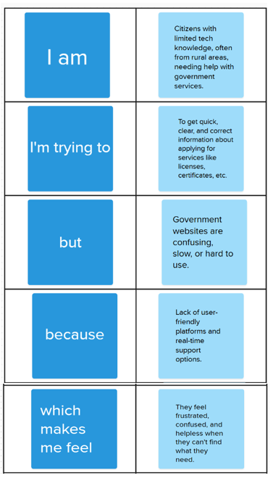

**Example:**

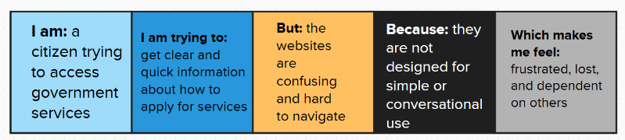

|  |  |  |  |  |  |
| --- | --- | --- | --- | --- | --- |
| **Problem Statement (PS)** | **I am (Customer)** | **I’m trying to** | **But** | **Because** | **Which makes me feel** |
| PS-1 | A citizen with limited tech skills | Get information about applying for a driving license | I can’t find the right steps easily | Government websites are complex and not user-friendly | Frustrated and dependent on others |
| PS-2 | A rural citizen | Ask a question about a government service | There’s no easy way to get answers quickly | There is no conversational or AI-based support | Confused, helpless, and ignored |